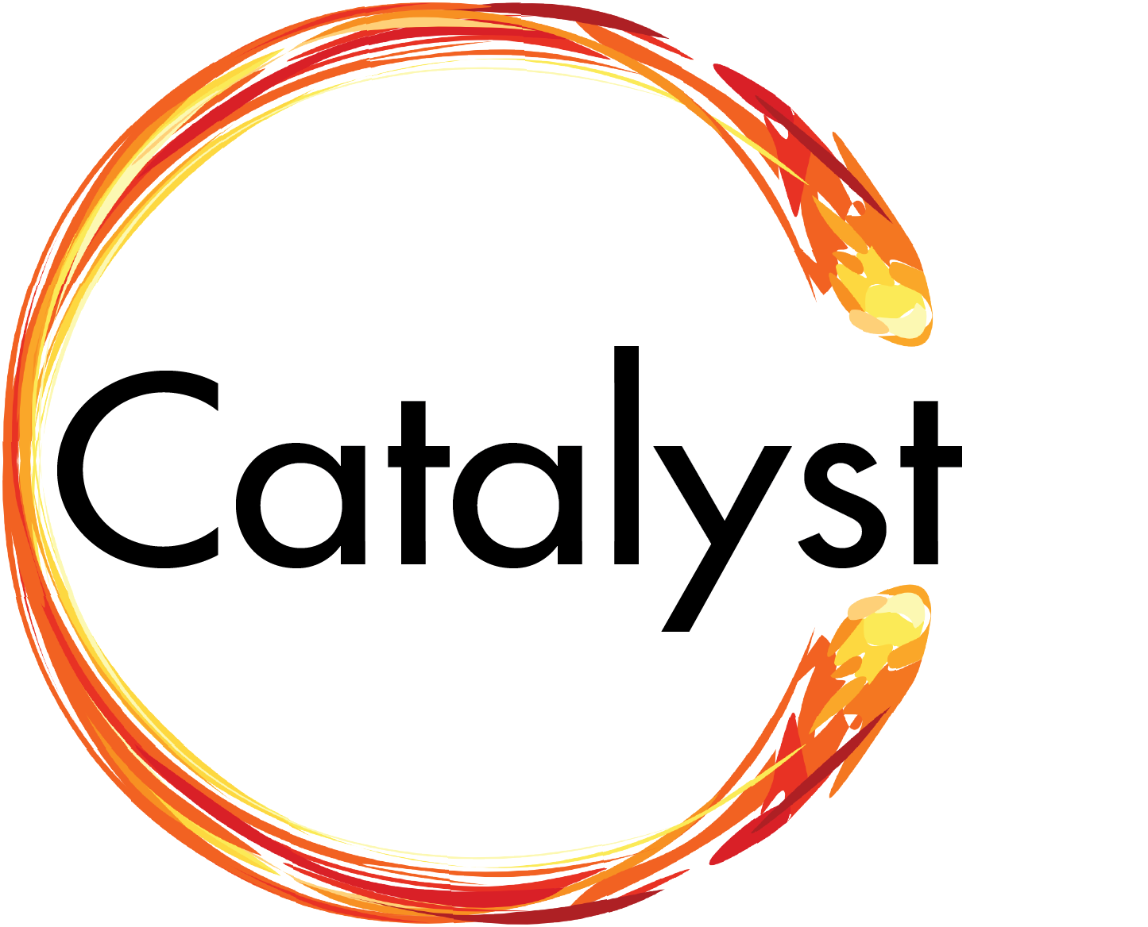
Application for Catalyst Program
City of Lawrence Development Assistance

Economic development assistance is available for industrial building projects to be located within Lawrence VenturePark, East Hills Business Center, or throughout the City on IG zoned land. In addition to this application, Applicant should submit a request letter that introduces the company and potential project. The letter should mention any benefits the project would bring to the community, including the number of jobs anticipated to be created and average wages. Note if the project is approved for Catalyst, incentives will not depend on meeting these estimates.

Send completed/signed application and request letter to:

City of Lawrence, Kansas
City Manager’s Office, Economic Development Coordinator
6 East 6th Street, Lawrence, KS 66044 bcano@lawrenceks.org

Applicant Information
Name:
Title:
Company/Organization:
Address 1:
Address 2:
Phone:
Email:
Fax:

Project Information
Building Location/Address (specify park name and Lot(s):
Construction Type | Size (sf)
New Construction, Free-Standing Building:
New Construction, Expansion of Existing Building:
If Expansion, Address of Existing Building:
Estimated Construction Start:
Estimated Construction End:
Project to be Built to LEED Equivalent Level
Certified:
Silver:
Gold:
Platinum:

Is Applicant a taxable entity?
Will project be taxable?
Applicant is current on all property tax, special assessments, or any obligations to the City of Lawrence? (Y/N)
If not, please explain:
Marketing Expertise (spec buildings only)
Please provide details on how the project will be marketed:
Attach additional documentation regarding marketing team, qualifications, expertise, and past experience in successfully marketing similar properties.

Financial Capacity
Total Building Investment: | Labor Expense:
Total Building Investment: | Construction Materials:
Total Building Investment: | Other (please describe):
Total Building Investment: | Estimated Total Building Investment:
Please provide details on how the project will be funded, including sources and amounts (e.g. owner equity, lender commitments, investor commitments, additional funding sources)
Attach additional documentation regarding financial capacity to successfully fund similar projects.

I hereby certify that the foregoing and attached information contained is true and correct, to the best of my knowledge:

Applicant Signature: Date:

Disclosures
Company Form of Organization:
It is the policy of the City that no economic development incentive will be granted to any applicant or petitioner who owns any financial interest in any real property, anywhere within the state of Kansas, with delinquent special assessments, delinquent ad valorem taxes, or federal or state tax liens, or who is currently delinquent or in default on any debts, responsibilities, or other obligations owed to the City.

List the full name(s) of each principal (partner or member) who owns (or will own) 5% or more capital of the company. In the case of businesses owning another business (such as an umbrella LLC that is the owner of several other LLC's), the actual partners' names need to be listed, not just the registrant's name with the Secretary of State.

Are all above listed principals currently delinquent or in default on any debts, responsibilities, or other obligations owed to the City? If delinquent or in default, provide details on property owner name, property address, current property tax status, special assessment status, and outstanding obligations owed to the City, and why delinquent or in default.

List all subsidiaries or affiliates and details of ownership:
Subsidiary :
Principals:
Has Company or any of its Directors/Officers been involved in or is the Company presently involved in any type of litigation?
Has the Company, developer or any affiliated party declared bankruptcy?
Has the Company, developer or any affiliated party defaulted on a real estate obligation?
Has the Company, developer or any affiliated party been the defendant in any legal suit or action?
Has the Company, developer or any affiliated party had judgments recorded against them?
If the answer to any of the above question is yes, please explain:

Note: Applicant may be required to provide additional financial information for the project and company.
Notice of Fees: 3rd Party Services
Applicant is responsible for paying all expenses incurred by the City for professional services pertaining to the project, regardless of if the project is approved. This may include costs associated with research and analytical services, legal publication notices, application fees to the state Board of Tax Appeals, bond counsel and other miscellaneous costs, including but not limited to, the City reasonable costs to process any modifications.

AFFIDAVIT

THE STATE OF _____________ )
) ss:
THE COUNTY OF ___________ )

I, _________________________________, being of lawful age, and having been first duly sworn upon my oath, do hereby state:

1. I am a resident of ___________________, ______________.

2. As of the date set forth below, I have no financial interest and no entity in which I have any interest has any financial interest in any real property, located anywhere in the state of Kansas, that is delinquent on any special assessments, delinquent on any ad valorem taxes, or the subject of any federal, state, or local tax lien.

3. As of the date set forth below, I am not currently delinquent or in default and no entity in which I have any interest is currently delinquent or in default on any debts, responsibilities, or other obligations owed to the City of Lawrence, Kansas.

________________________________

SUBSCRIBED AND SWORN before the undersigned on this _____ day of _________________, 201_.

________________________________
Notary Public

My Appointment Expires:

